Depolymerization of Polylactic Acid: Saponification to Lactic Acid

**Reference:** Handout; Chemistry lessons: basic hydrolysis (saponification); Green lessons: design for degradation, atom economy, catalysis, safer solvents and reagents; Bruice pg. 706

**Purpose:** To depolymerize polylactic acid to produce lactic acid by saponification

**Table of Reagents:**

|  |  |  |  |  |  |
| --- | --- | --- | --- | --- | --- |
| **Compounds** | **MW** | **Amount** | **BP (°C)** | **MP (°C)** | **Density** |
| Polylactic Acid | 296.40 g/mol | 5.0 g | - °C | 150 °C | 1.210 g/cm3 |
| NaOH | 39.997 g/mol | 5.6 g | 1388 °C | 323 °C | 2.13 g/cm3 |
| Ethanol (EtOH) | 46.069 g/mol | - | 78.2 °C | -114.1 °C | 0.789 g/cm3 |
| HCl | 36.450 g/mol | - | -85.05 °C | -114.2 °C | 1.19 g/cm3 |

**Balanced Chemical Equation:**

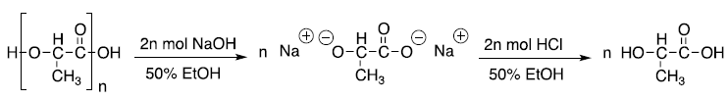

**Mechanism:**

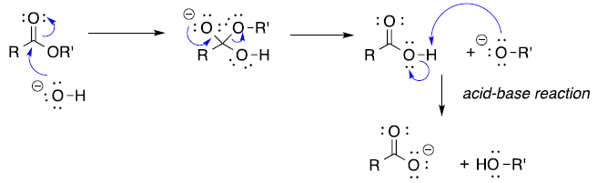

**Safety:**

* Sodium hydroxide 🡪 corrosive; wear goggles and gloves

|  |  |
| --- | --- |
| **Experimental Procedures** | **Data & Observations** |
| **1.** Obtain 5 g of shredded PLA and 5.6 g of NaOH   * Add to a 250 mL Erlenmeyer flask with a stir bar * 2:1 molar ration of NaOH:PLA needed |  |
| **2.** Add NaOH to fill the remainder of the flask up and cover the flask with a watch glass |  |
| **3.** Heat the reaction to boil for 1 hour to complete the hydrolysis of PLA |  |
| **4.** Place reaction in an ice bath and add HCl until the pH is 3.8 |  |
| **5.** Filter to remove any residuals; filtrate should be the lactic acid and NaCl |  |

**Post-lab Questions:**

**1.** 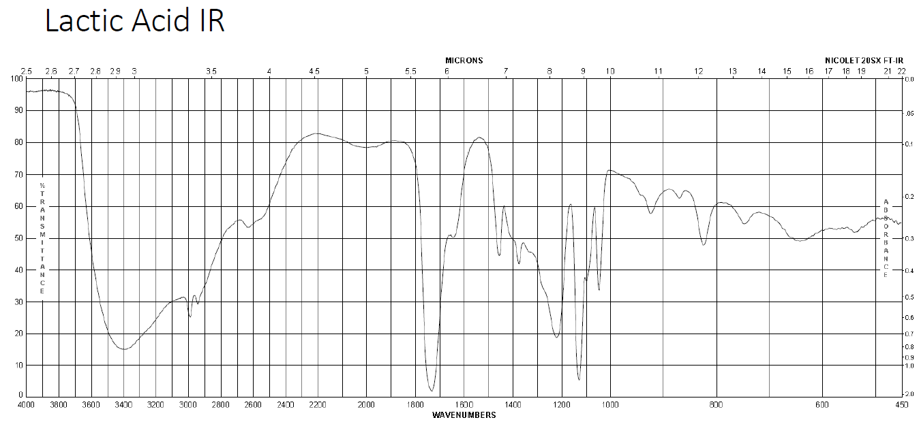



**2.** a) The 1H NMR spectrum of lactic acid would display *4 different peaks*.

b) The 13C Nmr spcetrum of lactic acid would display *3 different peaks.*

c) Arrow-pushing mechanism for the basic hydrolysis of PLA

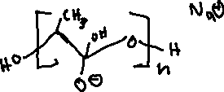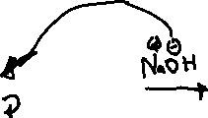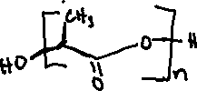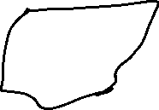

**3.** a) The saponification produces sodium lactate as the final product, however, when HCl was added the organic product produced was *lactic acid*.

b) Saponifcation produces sodium lactate as the final product rather than lactic acid because during the saponification process our carboxylic acid is stripped of its proton due to its low pKa value which is then given to the alkoxide.

c) The pKa of lactic acid is 3.85, so in order for the reaction to favor the production of lactic acid the pH must be below 3.85, which makes it favorable for the carboxylic to keep the proton in forming lactic acid.

**4.** a) The lab was considered green for many factors, which mainly stems from that fact that the lab produced little waste as well as the product was biodegradable. In addition, the lab used safe chemicals and solvents along with having a high atom economy (efficiency that all reagents were turned into the product).

b) The basic method is greener as it is safer for the environment, since no harmful products are created. In addition, the acidic method is also much slower in comparison with the basic method.

**5.** While some plastics are made from renewable resources, most plastics in fact are made from non renewable resources such as oil and natural gas. This limitation in supply means that once our resource is gone, then we are forever voided of the resource. One example for instance, polyvinyl chloride, we see that it is one of the most common household plastics as well as it is the 3rd most widely produced synthetic plastic next to polyethylene and polypropylene. This synthetic plastic is used in our everyday pipe system as well as in our tubing and wires. It is derived from petroleum, a non-renewable resource, and its IUPAC name is chloroethene.